# Exercises: Containers and Docker

Exercises for the "Containers and Clouds" course @ SoftUni

## Lightstreamer Container

Lightstreamer ([https://lightstreamer.com](https://lightstreamer.com/)) is a **web-based asynchronous messaging project**.

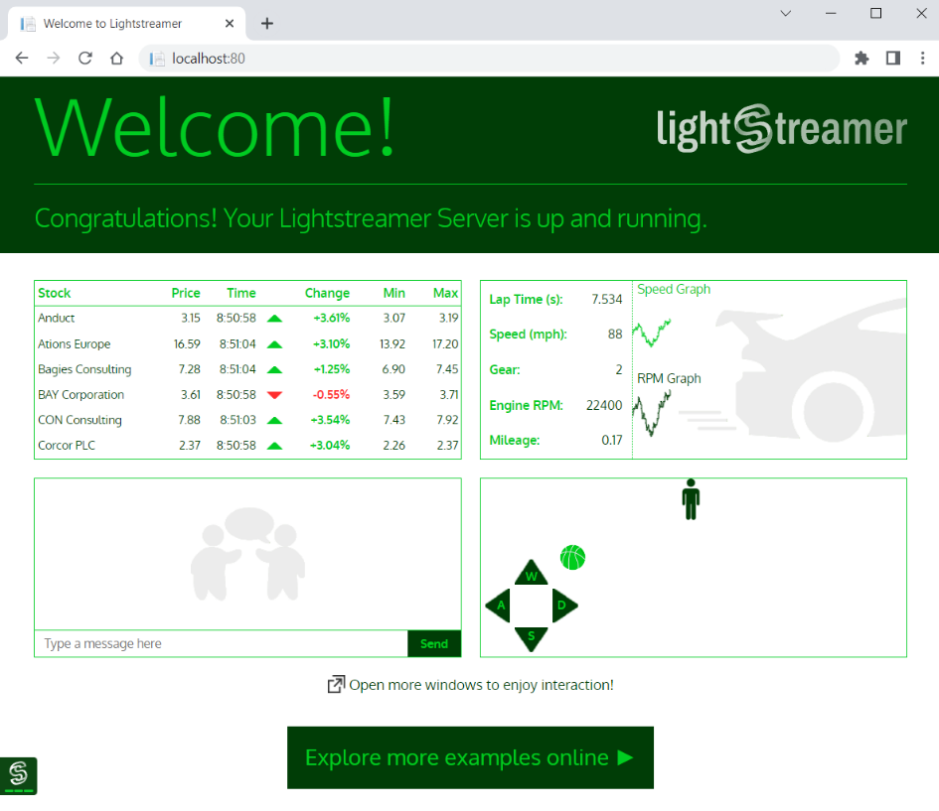

Your task is to **run it in a Docker container**. For running the Lightstreamer **container**:

* The **image** you need is lightstreamer:latest
* Your **container's name** should be ls-server
* Server works on port 8080, but should be accessed on localhost:80
* Container should be run in detached mode

Your container should look like this:

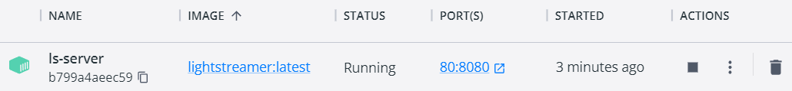

Make sure your **container is created** and Lightstreamer **works in the browser**. Then you can **delete the container** and the **image**.

## Ghost Container

Ghost (<https://en.wikipedia.org/wiki/Ghost_%28blogging_platform%29>) is a free and open-source **blogging platform**, written in **JavaScript**. When **run in** a Docker **container** and **accessed in the browser**, it looks like this:

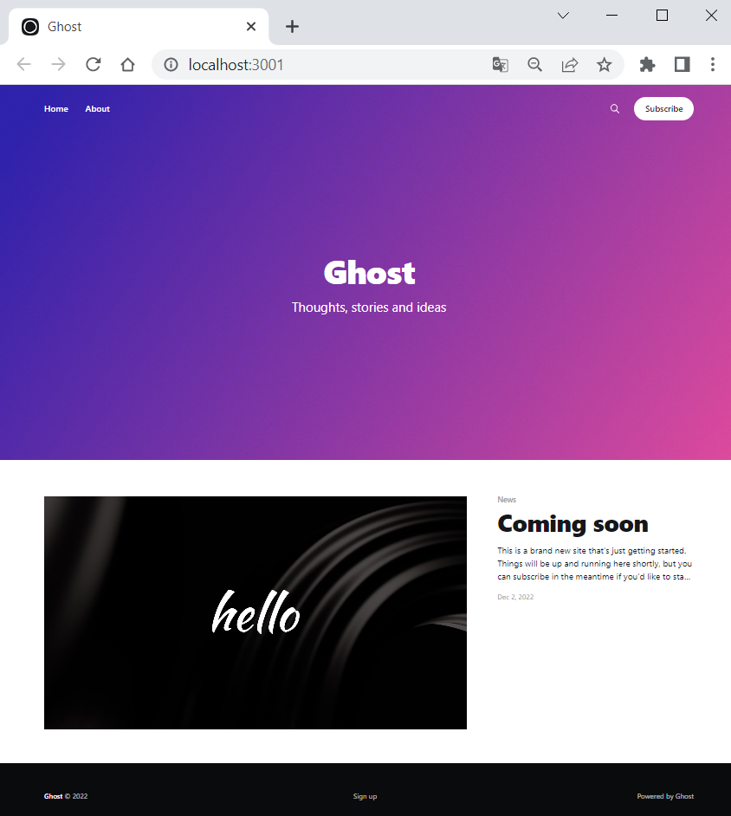

For running your Ghost **container**, follow these **requirements**:

* The **image** you need is ghost:latest
* Your **container's name** should be ghost-container
* Server works on port 2368, but should be accessed on localhost:3001
* You should set NODE_ENV=development as an **environment variable** with the -e **option**
* Container should be run in detached mode

Your container should look like this:

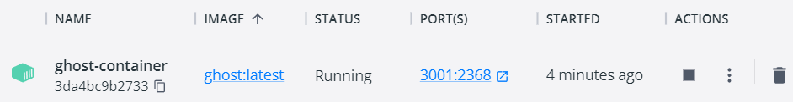

Note: if a "We'll be right back" **message** appears in the browser, it means that **Ghost is still loading**, so **refresh the browser** and everything should be alright.

## Apache HTTP Server Container

Now you should run Apache HTTP Server in a Docker **container**.

* Use the **latest image:** httpd:latest

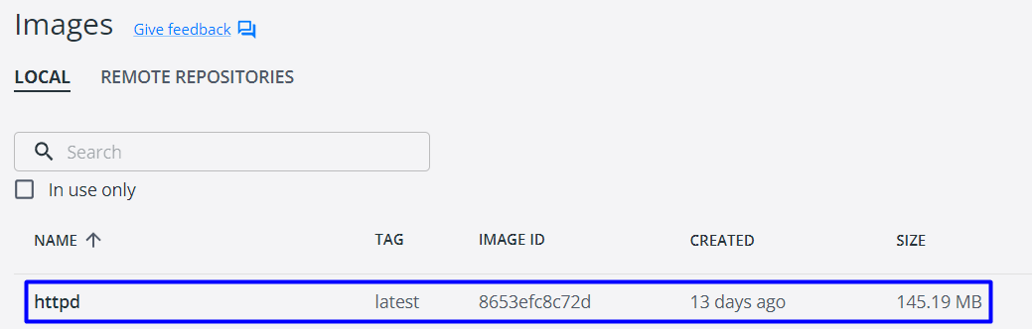

* Your **container's name** should be my-apache-app
* **Server** works on port 80, but should be accessed on localhost:8080
* Container should be run in detached mode
* You should create a volume – map current PowerShell (or another) directory to the container's directory /usr/local/apache2/htdocs/

Your container should look like this:

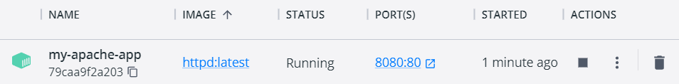

When accessed from the browser, it should list the files and folders from your local file system in the PowerShell directory you provided the server with, as well as in child directories: Картина, която съдържа текст

Описанието е генерирано автоматично

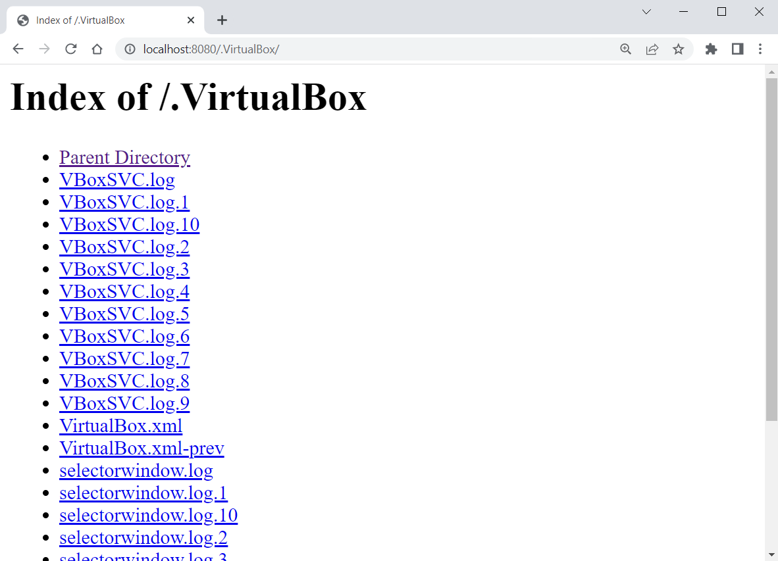

The **local file system** is accessed by the **container** because of the **volume**.

However, if the browser only shows you the "It works!" **message** (see below), then you **didn't succeed in running the container properly** and you should **fix your command and try again**:

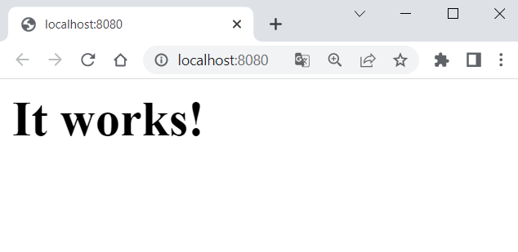

## SQL Server Container

Our task is to **run a container** with an SQL Server **database** in it. To do this, we will need the **following image** from Docker Hub: <https://hub.docker.com/_/microsoft-mssql-server>.

You can look at the "How to use this Image" **section** to learn how to **run the database container**. However, we will also **show and explain** this step by step.

### Create the Container

Start **writing the multi-line** run **command** for the Docker **container**:



Let's first take care of the **environment variables** needed for the **SQL** **Server** **container**. We should **confirm the acceptance to licensing agreement** with ACCEPT_EULA=Y:



We should also **set a password** for the **database system administrator** (sa) to **connect to SQL Server** once the container is running:



Note: your **password** should follow the **requirements** **from the documentation**: "This password needs to include at least 8 characters of at least three of these four categories: uppercase letters, lowercase letters, numbers and non-alphanumeric symbols".

Next, we should **expose a port for the container**. The server works on port 1433 and we will start it **locally** **on the same** one:



Then, we should **create a volume**, otherwise **data will be lost** when container is stopped, which is bad for a database container. We will name our **volume** sqldata and map it to the /var/opt/mssql **directory**, where **SQL Server data is stored**:



At the end, we will use the -d **option** to run the container in **detached mode** and will use the mcr.microsoft.com/mssql/server **image**:



Note: we **didn't pull the image in advance** but don't worry – it will be **pulled automatically** when the docker run command is executed.

**Execute** the above command and the **container should be created**:

